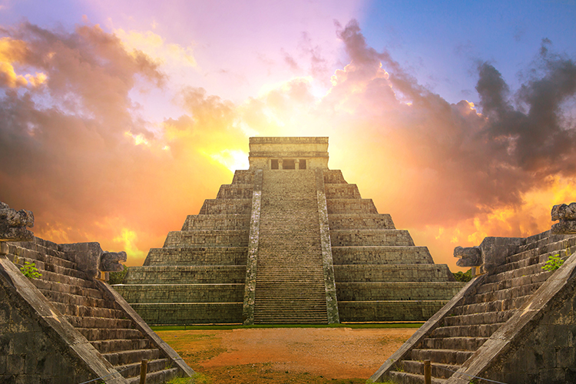

**Chichen Itza**

Chichén Itzá, a marvel of ancient Mayan engineering and cosmological significance, stands as a testament to a sophisticated civilization's architectural prowess and cultural legacy.

**History**

Chichen Itza, an ancient Mayan city in Mexico, stands as a testament to the advanced civilization with its iconic pyramid, El Castillo, showcasing astronomical precision and cultural significance.